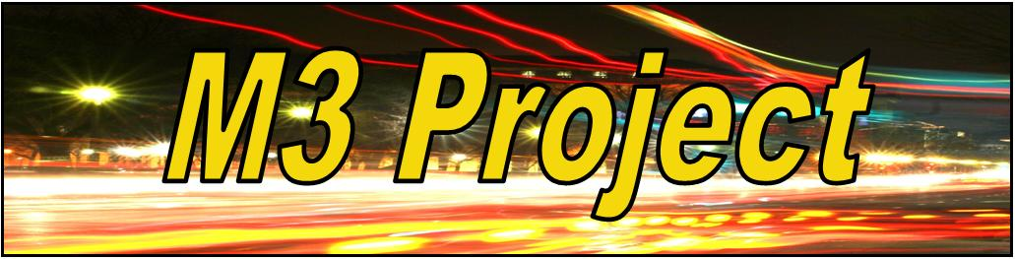

M3 Project Ltd MODERN SLAVERY STATEMENT 2018/19
This statement has been published in accordance with the Modern Slavery Act 2015 and the Modern Slavery Act (Transparency in Supply Chains) Regulations 2015. It sets out the position and steps taken by M3 Project during the year ending 30 September 2019 to prevent modern slavery and human trafficking in its business and supply chains.
Introduction
We know that slavery, servitude, forced labour and human trafficking (Modern Slavery) is a global and growing issue. At M3 Project, we have a zero tolerance approach to Modern Slavery of any kind within our operations and supply chains. We all have responsibility to be alert to the risks and to take appropriate action as necessary. There is an expectation on staff to report concerns, using the appropriate channels, and management is expected to act upon all concerns raised.
Our business and supply chains
M3 Project is a housing and homeless support charity, based in NW England. During the last year we supported over 50 young people through the services we provide in 20 or more locations operating across East Lancashire. This was achieved through the efforts of our staff team, peer mentors and volunteers. M3 Project has an annual turnover of £300k and a small group of suppliers. Our supply chains most at risk from Modern Slavery are deemed to be (i) providers of temporary staff (ii) building contractors (iii) cleaning contracts and (iii) IT equipment providers.
Due diligence
Our suppliers are required to confirm compliance with relevant legislation including the Modern Slavery Act as required.
Training & awareness
M3 Project specifically covers Modern Slavery Act training within its safeguarding training and support. This is further supported by appropriate internal communications.
Policies and controls
We have a range of policies and controls which have been enhanced to specifically address the risks from Modern Slavery. These include:
o Whistleblowing Policy o Compliment, Comment and Complaint Form o Recruitment & Selection Policy o Safeguarding Adults Policy o Safeguarding Children Policy

Steps taken & future action
Work continues to monitor the work of suppliers and enhance policy controls in the supply chain.
Approval
This statement has been signed off by the Chair of Trustees on behalf of the Board of Trustees.

